Pizza Bomb

Retrospective

**Index**

1 Introduction 1

2 Initial Planninng 1

2.1 Art Direction 1

2.1.1 Concepting 1

2.1.2 Moodboard 1

2.1.3 Color Palette 1

2.2 Blockout 1

3 Asset Creation 2

3.1 Atlas Based Assets 2

3.1.1 Overview 2

3.1.2 Wallkit 2

3.1.3 Furniture 4

3.1.4 Cleaning 4

3.1.5 Floor 5

3.1.6 Wrestling 5

3.2 Hand Textured Assets 5

3.2.1 Overview 5

3.2.2 Food 6

3.2.3 Additional Assets 6

4 Material Setup in Unreal 6

5 Lighting Color Grading & PBR Adjustments 8

6 Conclusion 9

7 Bibliography 10

# Introduction

This project involved creating a top-down environment in Unreal Engine 5.6, optimized for mobile platforms. The main objective was to design and produce a complete interior scene while adhering to technical constraints, including a polygon limit of 300,000 and a maximum texture resolution of 1024×1024 for all textures. The purpose of the project was to understand the full environment art workflow, from concepting and blockout to modeling, texturing, and lighting. Gaining hands-on experience in each stage helped build a clearer understanding of the entire production pipeline and how each step affects the next, which is crucial for efficient planning and collaboration in professional workflows. On a personal level, I aimed to achieve strong visual consistency across the scene and to create an environment that feels believable and lived-in, where the space naturally conveys human presence and use.

Since the task was completed individually, I assumed multiple roles typically, including environment artist, lighting artist, and art director. This structure provided valuable insight into how these disciplines interconnect within a professional production pipeline and how artistic and technical decisions affect one another.

**Add roadmap**

# Initial Planninng

## Art Direction

### Concepting

My workflow began with a conceptual phase, where I defined the theme, tone, and atmosphere of the environment. The idea of combining a pizzeria with a wrestling ring presented both artistic and design challenges, requiring me to merge two very distinct aesthetics into a single coherent visual style. The goal was to make the space feel lively and authentic while maintaining a stylized and readable look suitable for a top-down mobile environment.

### Moodboard

### Color Palette

## Blockout

For the blockout stage, I chose to work directly in Unreal Engine. This allowed me to rapidly iterate on layout, scale, and player navigation without being distracted by detail modeling. Using mannequins as stand-ins for people helped me visualize proportions, circulation paths, and sightlines. I also implemented a navigation mesh early on to ensure the space was functionally navigable before committing to detailed models. This approach mirrored professional workflows where early spatial testing prevents downstream issues in navigability or design.Ein Bild, das Himmel, Gebäude, Architektur, Screenshot enthält.

Blockout before starting with any assets

# Asset Creation

## Atlas Based Assets

### Overview

To construct the environment efficiently within the given technical constraints, I developed several modular asset sets: a Wall Kit, Flooring, Food Props, Cleaning Props, Wrestling Props, and a selection of additional hand-painted props. Wherever possible, I relied on trim sheets to optimise performance, reduce texture memory usage, and maintain visual consistency. The use of trim sheets also allowed for faster iteration and easier color adjustments later in Unreal Engine. This approach reflects a standard industry practice where modularity and reusability are prioritised to balance visual quality with production efficiency.

### Wallkit

The wall kit represented one of the most complex elements of the project due to the need for precise modular alignment and consistency across curved and straight wall sections. Each wall module had to fit seamlessly with others, both visually and technically, to allow flexible assembly inside Unreal Engine.

To achieve this, I implemented a curve-driven modeling workflow in Blender. Wall geometry was generated from a single cross-sectional profile that was instanced along curve splines, allowing for smooth transitions and consistent wall thickness regardless of curvature. Adjusting the profile or dimensions of one curve automatically updated all wall modules, significantly accelerating the iteration process. This system also made it easier to maintain accurate proportions and uniform detail levels across the entire kit.

**Ein Bild, das Screenshot, Design, Hebel enthält.
**

*Curve-driven workflow in Blender ensured consistent wall thickness and easy modular variation*

Initially, the wall kit was composed of multiple smaller modular pieces joined in-engine. However, this caused light baking issues due to overlapping vertices at seams. Through testing, I discovered that pre-merging wall sections in Blender before importing resolved these artifacts while maintaining sufficient flexibility for layout changes. This adjustment demonstrated the importance of testing and problem-solving in a-standard workflow, where technical and artistic requirements often evolve in parallel.

Ein Bild, das Wolke, Himmel, draußen, Gelände enthält.

Finished Wallkit

### Furniture

The furniture served as one of the main visual anchors of the environment, designed to reflect the look and atmosphere of a classic American diner. The pieces were characterized by rounded metal edges, polished surfaces, and vinyl textures that contributed to the familiar retro aesthetic. To maintain visual clarity from the top-down perspective, the materials and forms were slightly stylized, emphasizing bold shapes and clean color contrasts rather than fine surface detail.

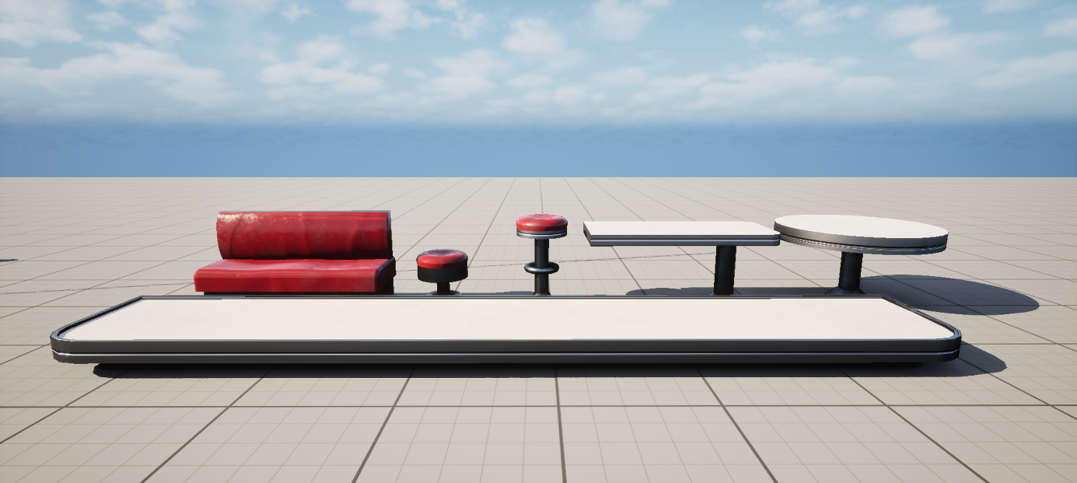

Furniture Kit

### Cleaning

The cleaning kit was another example of efficiency in asset reuse. Items like mops, buckets, and cloths were small but important storytelling elements that contributed to the believability of the space. Despite their secondary role, these props shared materials with other assets through the same texture atlas, reducing overhead while reinforcing the scene’s sense of wear and imperfection.

Ein Bild, das Himmel, Wolke, draußen, Gelände enthält.

Reused texture atlas for cleaning props to minimize texture count and maintain performance.

### Floor

### Wrestling

## Hand Textured Assets

### Overview

Some props needed to be hand textured, since they did not fit any trimsheet and were to specific. As much as I tried to avoid having to do that it turned out that some assets still required indidviaul textures. I tried to cut down the amount of hand tetured assets to a mininmum though.   
The only hand textured props are the food props, the suitcase in the center, the boxing machine and the slotmachines. These assets were way to specific and did not use materials I reused somewhere else

### Food

Ein Bild, das Wolke, Himmel, draußen, Flasche enthält.

### Additional Assets

Ein Bild, das Himmel, Wolke, draußen, Gelände enthält.

# Material Setup in Unreal

Most assets in the scene were built using a single master PBR material in Unreal Engine. Each asset utilized three primary texture maps: Base Color, Normal, and a packed MRA map containing Metallic, Roughness, and Ambient Occlusion information. Ambient Occlusion was only applied to the hand-textured assets, as it provided additional surface depth and variation that could not be achieved through tileable textures alone.

A used material function to allow quick adjustments in the material like changing roughness, normal or albedo values in a material instance quickly to test different visual looks or fix small issues right in Unreal

Ein Bild, das Screenshot, Text, Multimedia-Software, Software enthält.

Quite simple structured material easily letting me read what my shader is doing without seeing too much detail under the hood

A custom material function was implemented to allow quick and flexible adjustments within material instances. This setup made it possible to modify parameters such as roughness, normal intensity, or albedo values directly in Unreal without returning to external texturing software. This workflow significantly improved iteration speed, especially during the lighting and polishing stages, where subtle changes in material response could have a major visual impact.

Ein Bild, das Screenshot, 3D-Modellierung, Grafiksoftware, Spielesoftware enthält.

The material function that allows quick adjustments to a material inside Unreal Engine

# Lighting Color Grading & PBR Adjustments

This part was arguable the hardest. I had only once done interior lighting in Unity and was very unfamiliar with the light baking process in Unreal and how to prepare meshes and everything. I remember it was a struggle last time in Unity when I made it and it took me weeks just to get baked lighting exactly the way I wanted it. It took me about a week just to get the lighting right. I tried many interioations. My main problem was that I wanted to use a directional light to light my scene. However the problem with it was that its shadows where way to harsh. This cause a problem where the center ring and stage were no present enough due to their low contrast ratio into the already existing harsh shadwos. I decided against using the directional light in the end and just simulate sunlight coming in wihta couple rect lights outside the windows.

I also learned to pay attention to give my materials physically accurate albeods. I compated my materials brightnesses to the brightnesses of <https://physicallybased.info/> to get a grasp of what my brightness should be. I noticed that a lot of my materials were way too dark for my scene. So I tweaked everything (espcialy the metals) to look right in Unreal.

Another big problem I personllay had was that I did a lot of lighting with volumentric lights using lumen and was mainly used to having the opportunity to either have volumentric lights or fake volumentric with meshes, However since I could not do either since transparent materials in general should be avoided in this project I could not do either which was an uknow limitaiotn that I was not oused.

I also tried paying extra attention to my color palette. I noticed a lot of materials look off in my lighting setup or colors did not match in some cases, so I made according adjustments to fit into my color palette.

This is also the part that I wished I had a lot more time to do. Even though I spend around a week of the whole project I wished I had already at least planned the light locations in the blockout so I spend more time tweaking the lights in the end but not placing them and thinking about when making the assets but before would probably have saved me a lot of time.Ein Bild, das Screenshot, Cartoon, Boden, Im Haus enthält.

Final Result

I noticed that there needs to be a lot more planning than I thought I would it. I went into the project a little blind. I think I can take away two things from this project.   
I should try to plan as much as possible, especially when doing trimsheets to use them more efficiently and the second thing is that I need to do my lighting with my blockout already and later add the assets. That brings me two main advantages: I instnaly see what my assets look like in the ligtnig senceraion I need them without needing to do al lot of ajdusemnts later and I also am able to make a lot of changes to my assets to account for specific lighting scneeariso (windows, holes in the wall and floor etc.).

The second thing I can take away is to spend more time on doing the lighting in general. I underestimated the amount of time it takes to make it look good. And since this is a super important topic because it can turn around the look of the entire level. I made over 100 different assets if I include multiple variations of levels. I can probably tone down the amount of assets I did and focus more on doing the lighting ineated

# Conclusion

.

# Bibliography